What is MACHINE LEARNING?

* <https://emerj.com/ai-glossary-terms/what-is-machine-learning/>
* *\* “Machine Learning is the science of getting computers to learn and act like humans do, and improve their learning over time in autonomous fashion, by feeding them data and information in the form of observations and real-world interactions.”*
* <https://www.spotlightmetal.com/machine-learning--definition-and-application-examples-a-746226/?cmp=go-aw-art-trf-SLM_DSA_IND-20190122&gclid=Cj0KCQjwu8r4BRCzARIsAA21i_CD3lxQJiGdNgJmK-PaECx2TkBE6puiTWJGGSb29lCme5tGU9DPuGUaAiiLEALw_wcB>

Types of Machine Learning

Basically, algorithms play an important role in Machine Learning: On the one hand, they are responsible for recognizing patterns and on the other hand, they can generate solutions. Algorithms can be divided into different categories:

* <https://expertsystem.com/machine-learning-definition/>

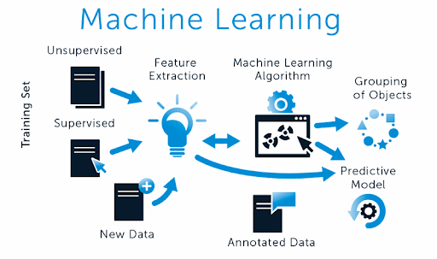

<https://devpost.com/software/machine-learning-to-solve-all-unsolved-problems> - Reference Image

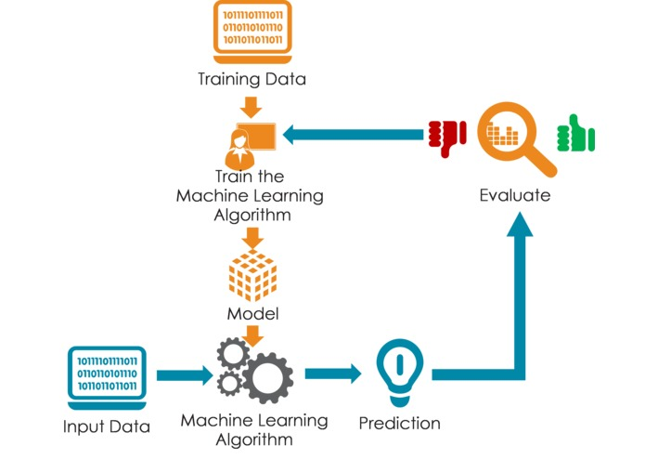

1. “Machine learning is the science of getting computers to act without being explicitly programmed.” – [Stanford](https://www.coursera.org/learn/machine-learning)
2. “Machine learning is based on algorithms that can learn from data without relying on rules-based programming.”- [McKinsey & Co.](http://www.mckinsey.com/industries/high-tech/our-insights/an-executives-guide-to-machine-learning)
3. “Machine learning algorithms can figure out how to perform important tasks by generalizing from examples.” – [University of Washington](http://homes.cs.washington.edu/~pedrod/papers/cacm12.pdf)